**KAMPALA URBAN SCHOOLS**

**BEGINNING OF FEBRUARY EXAMINATIONS, 2024**

**PRIMARY SEVEN MATHEMATICS**

**NAME:_________________________________________STREAM: _______**

**Section A (40 marks)**

1. Work out: 36 + 42
2. Write: in figures: Two thousand, six hundred forty one.

1. If F = {a, e, i, o, u} and G = {g, a, v, e}, find the complement of set F.
2. A farmer counted and tallied all his animals on the farm as follows:

How many animals does he have on the farm? ………………………………

1. A motor cycle uses 1 litre of petrol to cover a distance of 8km. what distance does he cover when he uses 13 litres of petrol?
2. Amanda has 2 packets of sugar. Each packet weighs 500grams. How many **kilograms** of sugar does Amanda have?
3. Use a pair of compasses and a ruler only, to bisect the angle below.
4. Find the next number in the sequence:

1, 3, 7, 13, 21, ………….

1. One evening, Patel was asked to tell the time shown on the clock face.

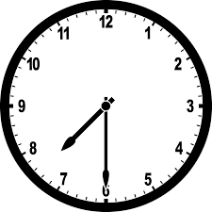 Write the correct time shown on the clock face.

…………………………………………

1. Calculate the product of 1673 and 42.
2. Town P is 180km from town Q. A cyclist travelled from P to Q at an average speed of 60km/hr. What time did he take?
3. The masses of 7 patients were recorded at a clinic as follows:

**70kg, 52kg, 67kg, 59kg, 50kg, 64kg,** and **60kg**.

Find their **median** mass.

1. Musa is 33 years old. Write his age in Roman numerals.
2. Calculate the distance round the shape below:

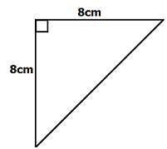

**12cm**

1. Work out: **-**7 + **+**2.
2. In Karibuni Forex Bureau, 1 US Dollar ($) costs Uganda shilling (UGX) 3600.

A tourist exchanged 400 US dollars. How much money in UGX did he get?

1. Shade 20% of the boxes below.

|  |  |  |  |  |
| --- | --- | --- | --- | --- |
|  |  |  |  |  |
|  |  |  |  |  |
|  |  |  |  |  |

1. Round off 2497 to the nearest tens.
2. Solve for e: 3(e – 2) = 6.
3. Work out the lowest Common Multiple (LCM) of 12 and 18.

**Section B (60 marks)**

1. The ministry of tourism recorded 78 tourists who visited the country during winter season. Of these, 40 visited Eastern Uganda (E), 35 visited Northern Uganda (N), x visited both regions and 5 visited neither of the regions.
2. 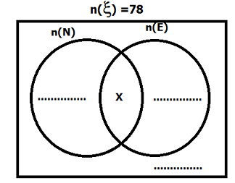Complete the Venn diagram below. ***(3 marks)***
3. How many tourists visited both regions? ***(3 marks)***
4. (a) Express $\frac{3}{4}$ as a decimal number. ***(2 marks)***

(b) Simplify: $\frac{1}{3}$ x $\frac{2}{5}÷\frac{1}{5}+\frac{1}{4}$. ***(3 marks)***

1. (a) Find the place value of 7 in 387994. ***(2 marks)***

(b) Add: 411five + 24five. ***(2 marks)***

1. The table below shows the number of pupils and how they scored in a Mathematics test. Study it and answer questions that follow.

|  |  |  |  |  |
| --- | --- | --- | --- | --- |
| Marks scored | 70 | 60 | 50 | 90 |
| No. of pupils | 3 | 4 | 2 | 1 |

1. How many pupils did the test? ***(2 marks)***

1. Find their range of marks. ***(1mark)***

1. Calculate their average mark. ***(3marks)***

25. (a) Work out: $\frac{1.2 x 0.06}{1.8}$***(3marks)***

(b) Express as a simple fraction: 0.3636…….. ***(2marks)***

26. (a) Find the volume of a cuboid whose length is 10cm, width is 9cm and the height is 7cm. ***(2marks)***

(b)Calculate the capacity of this figure, in litres***(2marks)***

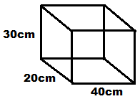

27. Study the shopping bill below and complete it correctly. ***(5marks)***

|  |  |  |  |
| --- | --- | --- | --- |
| **Item** | **Quantity** | **Unit cost** | **Amount** |
| ­Rice | 2 kg | Sh. 3000 per kg | **Sh**.**_______** |
| Bread | 3 loaves | **Sh**.**________** per loaf | Sh. 7,500 |
| Milk | _________**litres** | Sh. 2000 per litre | Sh. 3000 |
| Sugar | 1 kg | **Sh.________** per kg | Sh. 4000 |
| **Total Expenditure:** | | | **Sh._______** |

28. Using a pair of compasses and a ruler only, construct triangle ABC such that

AB = 7cm, angle A = 900 and AC = 5cm. ***(4marks)***

(b) Measure

(i) BC=………………. ***(1mark)***

(ii) Angle ABC = …………….. ***(1mark)***

29. Myles, Mary and Mildred shared sh. 48,000 in the ratio of 3 : 5 :4 respectively.

How much money did each get? ***(4marks)***

30. Find the value of angles m. ***(3marks)***

(a)

2m

500

(b) Find the value of n. ***(2marks)***

1200

n

31. A man deposited sh. 200,000 in Diamond Trust bank. He was given an interest rate of 20% per annum.

(a) Find his simple interest at the end of 4years. ***(2marks)***

(b) How much was his whole amount of money in the bank? ***(2marks)***

32. On the grid below, plot the following points:***(4marks)***

A(+2, **-**2), B(+4, +1), C(+2, +4) and D(-4, +1).

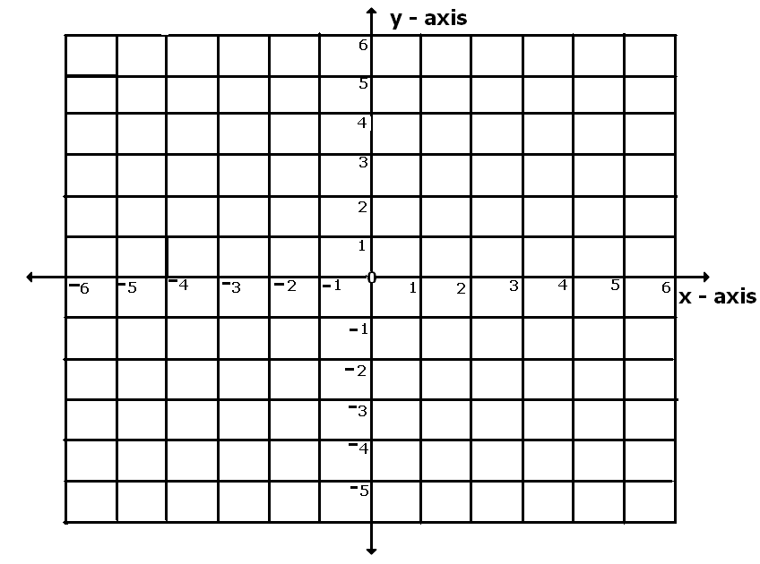

1. Join the point as follows to form a polygon: A to B to C to D.***(1mark)***

Name the polygon formed._______________________.

**Always wishing you the best**